
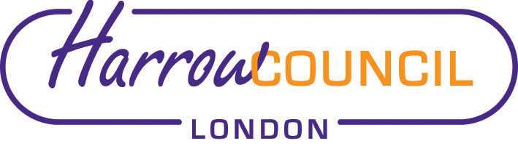
Harrow SACRE Meeting

Thursday 27 June 2019 at 7.30 p.m.
To be held in Committee Rooms 1-2
Harrow Civic Centre

Enquiries & apologies to:
Vivian Wright, Clerk to SACRE
vmwright@waitrose.com

Adviser to SACRE: Lesley Prior

Agenda
- Welcome:

- Apologies for absence: Mohammed Amar, Asad Omar, Sumana Sramaner

- Voting for Chair and Vice Chair

- Minutes of the last meeting on 19 March 2019: to agree the minutes as a true record.

- Matters arising from the minutes

- Monitoring of syllabus and websites

- News from NASACRE conference

- Determinations
- Norbury Determination
- Marlborough Determination

- Collective Worship working group

- Dates for religious days of worship up-date

- Website reviews in light of new Ofsted inspections

- Feedback from RE subject leader meetings

- LGBT and education

- Commission on RE: Final Report: schools’ briefing.

- News from Faith Groups relating to schools

- Any Other Business
- New Islam Resource for Schools and Teacher Pack
Comment from Asad: My comments about resource for Islam under AOB is that we should send the information to schools and let them decide if they want to buy the pack. We should stay neutral.

- Hindu Resource: audiobook, “The Ramayana: An Ancient Indian Epic”

- Future Dates

- Tuesday 15 October
- Tuesday 10 December
- Tuesday 24 March

